Effects of Seasonal Spill and Harvest Exposure on Steelhead Overshoot Fate at Wells Dam

  - Bayesian Hierarchical Analysis Using R/brms: 2005–2024



Prepared by:
Public Utility District No. 1 of Douglas County
East Wenatchee, Washington

May 2026

Abstract
Adult summer Steelhead (Oncorhynchus mykiss) born or acclimated in the Entiat and Wenatchee Rivers have been observed “overshooting” their natal tributaries and ascend Wells Dam fish ladders. These overshooting fish face uncertain fates, with potential consequences for population productivity and ESA recovery goals. Hydrosystem fall and late winter spill have been considered by hydro-operators and fish managers as a tool to aid overshooting adult Steelhead returning to natal streams prior to spawning. This study employed Bayesian hierarchical logistic regression to evaluate whether seasonal dam spill conditions and individual fish harvest exposure influence the probability that overshooting steelhead return downstream versus remain at Wells Dam. Analysis of 1,321 PIT-tagged steelhead across 20 years (2005–2024) revealed that neither fall nor spring spill magnitude nor frequency significantly influenced downstream return probability after accounting for harvest exposure. Harvest exposure, defined as hatchery fish detected during years when harvest was open, was the dominant predictor of fate, with harvest-exposed fish showing approximately 90% lower odds of returning downstream (β = −2.28; 95% HDI: −2.72, −1.87). These findings have important implications for understanding the mechanisms underlying steelhead overshoot mortality and informing management strategies at mainstem hydroelectric Projects for this ESA-threatened species.

Introduction

Conservation Significance
Upper Columbia River steelhead are listed as threatened under the Endangered Species Act (ESA), having been originally listed as endangered in 1997 and reclassified to threatened in 2006 (NOAA Fisheries 2024). The Wells Habitat Conservation Plan and Anadromous Fish Agreement specifically protects these ESA-listed fish using a “No Net Impact” methodology to protect them under Section 10 of the ESA. In addition to conservation aquaculture programs where Douglas PUD releases some 40,000 steelhead into the Twisp Basin annually, Douglas PUD releases another 277,000 juvenile steelhead either immediately below Wells Dam or in the Lower Methow River as a reservoir inundation and fisheries compensation program. The inundation compensation component is specifically designed to provide enhanced fisheries opportunities for anglers and is associated with the original reservoir inundation of Wells Dam. This program also serves as a safety net program that could support the conservation aquaculture program if necessary. Other agencies and tribes including the United States Fish and Wildlife Service, Grant County PUD and the Colville Confederated tribes have additional steelhead hatchery programs above Wells Dam.

Steelhead Overshoot Phenomenon
Most Anadromous salmonids exhibit remarkable natal homing fidelity. Adult Pacific salmonids return to their birth streams to spawn following a marine phase where growth and maturation occur. Adult steelhead exhibit complex adult return strategies (High et al., 2006), including variable migration rates once returning from the ocean and sometimes straying within and outside of their Distinct Population Segment (DPS). Further, a phenomenon known as “overshooting” occurs when adult fish migrate upstream past their natal tributary, often times passing one or multiple hydroelectric projects before subsequently attempting to fall back downstream (Keefer and Caudill 2014; Richins and Skalski 2018) to natal tributaries. The behavior has become more well known throughout the Columbia River basin, partly due to the advent of more robust PIT tag detection systems in fish ladders at mainstem hydroprojects and other systems in tributaries. It is largely unknown what proportion of steelhead that have overshot their natal tributary wish to return to said natal stream. Research suggests that some fish do return successfully, and fish managers assume some proportion are doing these overshooting behaviors only for a period of time before wanting to return to a natal stream to spawn (Murdoch et al., 2022). Some steelhead populations have been estimated to exhibit overshoot rates exceeding 50% (Richins and Skalski 2018; Murdoch et al. 2022) to 60% (e.g. Walla Walla; Min et al., 2025). Researchers have demonstrated that fish origin (hatchery vs. wild), natal tributary of origin, water temperatures, and juvenile transport experience can influence overshoot behavior and rates.
Murdoch et al. (2022) estimated that approximately 40% of the wild steelhead passing Priest Rapids Dam, the fifth mainstem Columbia River dam encountered by returning adults, are overshoot fish and perhaps as many as 40% of these overshoots fail to return downstream. While Steelhead have some of the most plastic life-history strategies in the Columbia River Basin, researchers have only limited data on what proportion of overshooting fish are natural strays (fish never intending to return to a natal stream), or unable to return to natal streams due to lack of surface passage routes at a hydroprojects, can locate a passage route at a dam but die during downstream passage, or might become subjected to unintentional or intentional harvest. These mechanisms and behavioral desires prove difficult to disentangle even in the most robust biotelemetry study designs.
Richins and Skalski (2018) documented that steelhead overshoot rates were strongly correlated with water temperatures near natal streams. Specifically, the probability of direct natal stream entry declined from over 90% to less than 25% as water temperatures increased from 10°C to 20°C. Similarly, Min et al. (2025) showed that across several DPS in the Columbia River, movement decisions were consistently thermally influenced with temperatures having a negative relationship with natal homing and a positive relationship with overshoot behavior and non-natal tributary use. These findings support the hypothesis that overshooting steelhead may be seeking coldwater thermal refugia upstream (WDFW 2024). Indeed, during some periods of the year, including those associated with summer steelhead returns at Wells Dam, mainstem temperatures above Wells Dam may offer the coldest water accessible in the Columbia River when compared to water temperatures lower in the basin or those in natal tributaries including the Wenatchee and Entiat Rivers.
Hatchery fish may also differ behaviorally from wild fish in ways that affect overshoot rates and fates. Richins and Skalski (2018) found that segregated hatchery stocks had 15% higher overshoot rates than wild or integrated stocks, and outplanted juveniles showed 65% higher overshoot rates than wild fish. Min et al. (2025) reached similar conclusions with not only higher overshoot rates in hatchery fish but improved natal return rates in wild fish following overshooting behavior.
The Columbia River basin presents unique challenges for returning adult salmonids. An adult steelhead migrating back to the Wenatchee River basin must navigate commercial and tribal fisheries, non-human predators including pinnipeds and avian sources, and pass seven hydroelectric projects. Adult Steelhead returning to the Entiat River Basin pass eight hydroelectric Projects. Steelhead born or acclimated in the Methow and Okanogan rivers , and overshooting steelhead from the Wenatchee and Entiat rivers pass Wells Dam, the ninth and final hydroelectric project on the mainstem Columbia River that allows fish passage.

Dam Passage and Spill Operations
Surface spill provided either immediately after summer steelhead upstream migration (August through November) or in the subsequent late winter (January through March) is considered by many fisheries managers as a useful tool to pass overshooting steelhead downstream safely (Murdoch et al., 2022), and yet its effectiveness is rarely demonstrated (Min et al., 2025). Spill programs are likely to be met cautiously by hydro-operators as spilled water can represent foregone generation during periods of high load need (electrical demand). Thankfully, more research is being completed on this important topic towards understanding the benefits if and where they exist. Min et al. (2025) examined 20 years of PIT tag data (2005-2024) for 37 Columbia River steelhead populations, river temperature data, and project operation data (spill) to examine how these factors influenced overshooting rates and return rates of these steelhead to natal rivers. Researchers showed that spill in January, February, and March at hydroelectric projects influenced return rates of over 60,000 adult steelhead dissimilarly. Only the Walla Walla River and Tucannon River Steelhead saw improved return rates under higher late winter spill regimes at Ice Harbor and Lower Granite Dams respectively. Conversely Steelhead born to the Entiat, Yakima, Wenatchee, John Day, and Umatilla river basins did not benefit from greater spill during the late winter period following overshooting a mainstem dams (Min et al., 2025). These findings suggest that late winter spill may not be useful for improving return rates at all hydroelectric Projects and that the benefits of late winter spill appears to be stock specific.
Importantly, researchers did not examine the influence of fall spill immediately following upstream migration of adult summer steelhead, nor the effects of fisheries in overshoot locations where overshooting steelhead may become subjected to said fishery. Whether fall or winter spill conditions influence the probability that overshooting steelhead successfully navigate back to their natal tributaries in the Entiat and Wenatchee rivers has not been systematically evaluated at Wells Dam, nor any mainstem Columbia River dam upstream of the confluence of the Snake River. Our lack of understanding regarding overshoot steelhead response to fall and spring spill at Wells Dam represents an important data gap, the filling of which has the potential to support the recovery of a threatened anadromous species.

Harvest Exposure
Fisheries for hatchery steelhead in the Upper Columbia have been subject to varying regulations over the past 20 or more years. For example, above Wells, steelhead harvest fisheries were open from 2000–2015 and again in 2024–2025, while emergency harvest closures were implemented from 2016–2023 due to low wild steelhead returns. Notably, harvest is used as a tool to reduce the number of hatchery origin fish that might otherwise escape to the spawning grounds while providing a popular fishery for recreational anglers. Mark-selective fisheries, like those above Wells Dam are governed by the adipose fin condition whereby adipose-fin-absent or “clipped” hatchery fish can be retained during an open fishery, whereas unmarked wild fish (adipose fin present) must be released. Open fisheries often assume that location-specific fisheries are mostly, or exclusively targeting, a certain population, but steelhead overshooting their natal tributary and instead spending time in an open fishery zone or area represents an unknown risk to successful natal return. Keefer et al. (2009) suggested that steelhead that use non-natal tributaries may be susceptible to permitted and unpermitted fisheries. No research papers exist where investigators examine the influence of fisheries on overshooting steelhead above Wells Dam. This literature void represents an important research question alongside spill regimes at hydroelectric projects as fish managers search for strategies to return overshooting steelhead safely to natal tributaries.
This paper aims to examine the influence of fall and late winter spill and exposure to fisheries to better understand what mechanisms play a role in return rates of overshooting Entiat and Wenatchee Steelhead at Wells Dam.

Study Objectives
This study tested two primary alternative hypotheses:
- Spill Hypothesis: Spill conditions at Wells Dam during the fall arrival period (August–November) or the subsequent late-winter holding period (January–March) influence the probability that overshoot steelhead return downstream.
- Harvest Exposure Hypothesis: Hatchery steelhead detected passing Wells Dam during years when harvest was open are less likely to be detected returning downstream than those passing during years when harvest was closed, either due to direct harvest mortality or behavioral differences.
We employed Bayesian hierarchical logistic regression to account for both individual-level (harvest exposure) and year-level (spill) predictors while appropriately modeling inter-annual variation in baseline return rates.

Methods

Study Area
The study focused on steelhead from the Wenatchee and Entiat River basins that were detected at Wells Dam on the Upper Columbia River. Wells Dam (river kilometer 830) is located upstream of these natal tributaries, and fish detected there have “overshot” their assumed desired spawning destination. Fish fates were classified based on their last PIT-tag detection: at Wells Dam (failure to return downstream, recognizing that they could have successfully passed downstream without detection anywhere downstream), downstream of Wells (successful fallback as indicated by a detection at an array downstream of Wells Dam, and thereby excluding undetected fallbacks), or above Wells (continued upstream migration to the Okanogan or Methow basins, as indicated by detection in those basins). For the purposes of analysis we focused on the first two groups; those that were last detected at Wells Dam and those that returned downstream of Wells.

Data Sources
PIT-tag detection records were obtained from PTAGIS using two queries. The first was to obtain all the steelhead released in Wenatchee and Entiat River Basin that were subsequently detected at Wells Dam (PTAGIS Site Code WEA) as an adult. All available Wenatchee and Entiat River release locations included in PTAGIS were included in query 1. Once this list was generated, the tag list from query 1 one was used to generate the complete detection histories of the fish identified in query 1. Query 2 yielded 1,355 unique fish and 9,688 detections of steelhead that overshot their natal tributaries (Entiat or Wenatchee) and were detected at Wells Dam (2001–2025). Because the WEA site includes antennas in the lower ladders (Pool 19) and at the ladder traps (Pool 40) where fish may be removed from the ladders, fish detected at WEA may not represent a passage event. Therefore, we QA/QC’d the Query 2 detections to censor PIT tags last detected at WEA but with no detections at the upper ladder pool near the exit (Pool 68) or indication of successful passage or post-handling transport above the dam. These removals included 34 fish and were distributed across multiple years, with the largest reductions in 2011 (5 fish), 2007 (4 fish), 2009 (4 fish), 2012 (4 fish), and 2006 (3 fish). The final dataset is summarized in Table 1. PIT-tag detection sites were classified by geographic zone relative to Wells Dam.

Table 1. Summary of steelhead used for analyses as generated from PTAGIS
Metric | Original
Total fish analyzed | 1,321
Fish returning downstream | 388
Fish remaining at Wells | 967
% returning downstream | 28.6%
Harvest-exposed fish | 1,149
% harvest-exposed | 84.8%

Hourly spill discharge measurements (kcfs) at Wells Dam from 2005–2025 were obtained from Columbia River DART (Data Access in Real Time). These data have been provided by Douglas PUD in near real time from project operation data at Wells Dam for multiple decades. Once the data were obtained from DART it was summarized in multiple ways including computing total spill hours in a period, number of spill days (days with any spill), and cumulative spill volume (kcfs-hours). Spill data were highly variable across the years representing a good continuum and dataset from which to test spill condition effect (Table 2). Spill data variability analysis is elaborated in Appendix A.

Table 2. Descriptive statistics for annual spill metrics at Wells Dam (2005–2024)
Metric | Mean | SD | Min (Year) | Max (Year) | CV (%)
Fall Total Spill (KCFS-hrs) | 5,195 | 2,021 | 724 (2024) | 9,667 (2013) | 39%
Fall Spill Hours | 535 | 158 | 52 (2024) | 725 (2021) | 30%
Fall Spill Days | 22 | 7 | 2 (2024) | 30 (2021) | 30%
Spring Total Spill (KCFS-hrs) | 3,448 | 4,738 | <1 (2010) | 17,709 (2017) | 137%
Spring Spill Hours | 146 | 162 | 1 (2010) | 671 (2018) | 111%
Spring Spill Days | 6 | 7 | 0 (2010) | 28 (2018) | 111%
CV = Coefficient of Variation (SD / Mean × 100%). Higher CV indicates greater interannual variability.

Fish rearing origin (hatchery or wild) was obtained from PTAGIS mark records. Annual harvest status for the study area was compiled from Washington Department of Fish and Wildlife regulations (WDFW), with harvest open 2000–2015 and 2024–2025, and closed 2016–2023.

Outcome Variable and Fate Classification
Fish were classified into three fates based on their last detection location as described above: (1) “Downstream,” last detected below Wells Dam, indicating successful fallback toward natal tributaries; (2) “At Wells, last detected at Wells Dam, suggesting failure to return downstream; (3) “Above,” last detected upstream of Wells Dam in non-natal basins. For the primary analysis, we modeled the binary outcome of Downstream (1) versus At Wells (0), excluding fish with Above fates.

Predictor Variables
Fish were assigned to a “spill year” using a June 1 cutoff: fish first detected at Wells Dam from June of year Y through May of year Y+1 were assigned to SpillYear Y+1 for spring spill and year Y for fall spill. Most overshooting steelhead arrive at Wells in late summer through fall, so this grouping pairs each fish with the fall spill conditions present during their arrival and spring spill conditions during the subsequent overwintering period.
For each spill year, three metrics were calculated: 1) Total spill hours, 2) number of spill days, and 3) cumulative spill volume (kcfs-hours) for two seasonal windows: 1) Fall spill (August 1–November 30), and 2) Spring spill (January 1–March 31).
A binary individual-level covariate was created for harvest exposure: Harvest Exposure = 1: Hatchery fish (Rear Type Code = “H”) detected at Wells Dam in a year when harvest was open (2000–2015, 2024–2025); and Harvest Exposure = 0: Wild fish, or hatchery fish detected in closed harvest years (2016–2023).

Statistical Analysis

Bayesian Hierarchical Logistic Regression
We fitted hierarchical Bayesian logistic regression models using the brms package (Bürkner 2017, 2018) in R version 4.3, which provides an interface to Stan for full Bayesian inference via Hamiltonian Monte Carlo. The brms package is widely used in ecological and fisheries research for fitting complex hierarchical models (Ogle 2024; Thorson and Kristensen 2024).
The model structure was:
$$\begin{matrix}y_{ij} & ∼\text{Bernoulli}\left(p_{ij}\right) \\ \text{logit}\left(p_{ij}\right) & α_{j}+β_{\text{spill}}⋅{\text{Spill}}_{j}+β_{\text{harvest}}⋅{\text{Harvest}}_{i} \\ α_{j} & ∼\text{Normal}\left(μ_{α},σ_{α}\right)\end{matrix}$$
Where: $y_{ij}$ = 1 if fish $i$ in year $j$ returned downstream, 0 otherwise; $α_{j}$ = year-specific random intercept (partial pooling across years); ${\text{Spill}}_{j}$ = standardized spill metric for year $j$; ${\text{Harvest}}_{i}$ = harvest exposure indicator for fish $i$

Prior Specifications
Weakly informative priors were specified to regularize estimates while allowing the data to dominate inference:
- $μ_{α}∼\text{Normal}\left(0,2\right)$ — population mean intercept
- $σ_{α}∼\text{HalfNormal}\left(0,1\right)$ — year-level standard deviation
- $β_{\text{spill}}∼\text{Normal}\left(0,1\right)$ — spill effect
- $β_{\text{harvest}}∼\text{Normal}\left(0,1\right)$ — harvest exposure effect

These priors are consistent with recommendations for logistic regression (Gelman et al. 2008) and ensure stable estimation with limited sample sizes in some years.

MCMC Sampling
Models were fitted using 4 chains with 4,500 iterations each (1,500 warmup + 3,000 sampling), yielding 12,000 posterior samples per parameter. The target acceptance rate was set to 0.95 (adapt_delta = 0.95) to minimize divergent transitions. Convergence was assessed using the Gelman-Rubin diagnostic ($\hat{R}$), with values <1.01 indicating convergence, and effective sample size (ESS), with values >1,000 considered adequate.

Models Fitted
Six hierarchical models were fitted, crossing three spill metrics with two seasonal windows: 1. Fall SpillHours + Harvest Exposure, 2. Fall SpillDays + Harvest Exposure, 3. Fall TotalSpill + Harvest Exposure, 4. Spring SpillHours + Harvest Exposure, 5. Spring SpillDays + Harvest Exposure, 6. Spring TotalSpill + Harvest Exposure

Inference
Posterior distributions were summarized using means, standard deviations, and 95% highest density intervals (HDI). The probability of direction, P(β > 0) or P(β < 0), was calculated to assess evidence for positive or negative effects. Effect sizes were also expressed as odds ratios by exponentiating the harvest coefficient: OR = exp(β_harvest).

Software and Reproducibility
All analyses were conducted in R version 4.3.2 (R Core Team 2023) using the following packages: brms version 2.21 (Bürkner 2017) for Bayesian model fitting; tidyverse (Wickham et al. 2019) for data manipulation; bayesplot (Gabry and Mahr 2022) for MCMC diagnostics; posterior (Bürkner et al. 2022) for posterior summarization; patchwork (Pedersen 2024) for figure composition

Results

Sample Summary
The analysis included 1,321 fish across 20 spill years (2005–2024). Of these, 381 fish (28.8%) were last detected downstream of Wells Dam and 940 fish (71.2%) were last detected at Wells Dam. A total of 1,126 fish (85.2%) were classified as harvest-exposed (hatchery fish in open harvest years).
Sample sizes varied substantially across years, from a single fish in 2022, 2023, and 2024 to 286 fish in 2010 (Table 1). The proportion returning downstream ranged from 4.0% (2005) to 100% (2022, 2023, 2024), with higher return rates generally observed during the harvest closure period (2016–2023).
Table 3. Fish fates, harvest exposure, and spill metrics by year
Year | Downstream | At Wells | Total | % Downstream | Harvest Exposed | Fall Spill (KCFS-hr) | Spring Spill (KCFS-hr)
2005 | 1 | 24 | 25 | 4.0% | 25 | 5,546 | 564
2006 | 4 | 53 | 57 | 7.0% | 57 | 6,330 | 1,611
2007 | 8 | 99 | 107 | 7.5% | 107 | 4,682 | 6,310
2008 | 11 | 80 | 91 | 12.1% | 88 | 4,960 | 153
2009 | 22 | 108 | 130 | 16.9% | 127 | 5,951 | 256
2010 | 80 | 206 | 286 | 28.0% | 257 | 3,866 | 1
2011 | 54 | 137 | 191 | 28.3% | 178 | 4,091 | 1,892
2012 | 46 | 84 | 130 | 35.4% | 114 | 6,876 | 2,877
2013 | 36 | 78 | 114 | 31.6% | 104 | 9,667 | 1,117
2014 | 19 | 16 | 35 | 54.3% | 21 | 4,207 | 2,903
2015 | 22 | 15 | 37 | 59.5% | 13 | 4,187 | 4,606
2016 | 35 | 27 | 62 | 56.5% | 35 | 4,098 | 165
2017 | 12 | 4 | 16 | 75.0% | 0 | 3,623 | 17,709
2018 | 8 | 3 | 11 | 72.7% | 0 | 4,904 | 14,037
2019 | 4 | 3 | 7 | 57.1% | 0 | 8,117 | 847
2020 | 8 | 2 | 10 | 80.0% | 0 | 5,134 | 3,547
2021 | 8 | 1 | 9 | 88.9% | 0 | 8,756 | 2,215
2022 | 1 | 0 | 1 | 100.0% | 0 | 3,912 | 7,001
2023 | 1 | 0 | 1 | 100.0% | 0 | 4,276 | 840
2024 | 1 | 0 | 1 | 100.0% | 0 | 724 | 306
Total | 381 | 940 | 1,321 | 28.8% | 1,126 | — | —
Note: Harvest was closed 2016–2023.

Model Convergence
All six models achieved excellent convergence. The Gelman-Rubin diagnostic ($\hat{R}$) was ≤1.01 for all parameters, and bulk effective sample sizes exceeded 3,000 for all fixed effects. Visual inspection of trace plots confirmed adequate mixing across chains (Figure 1).

Harvest Exposure Effect
The harvest-exposure effect was the dominant predictor of downstream return probability, with highly consistent results across all six models (Table 2). Harvest-exposed fish had substantially lower odds of returning downstream:
- Fall TotalSpill Model: β_harvest = −2.29 (95% HDI: −2.71, −1.88), P(β < 0) = 1.000, Odds Ratio = 0.10
- Spring TotalSpill Model: β_harvest = −2.28 (95% HDI: −2.72, −1.87), P(β < 0) = 1.000, Odds Ratio = 0.10

The harvest-exposure coefficient was negative and excluded zero in all models, with posterior probability of a negative effect equal to 1.000. The odds ratio of approximately 0.10 indicates that harvest-exposed fish had about 90% lower odds of returning downstream compared to fish without harvest exposure.

Table 4. Posterior summaries for all hierarchical models
Window | Spill Metric | β_Spill (Mean) | Spill 95% HDI | P(β_Spill > 0) | β_Harvest (Mean) | Harvest 95% HDI | Harvest OR | σ_year
Fall | SpillHours | −0.30 | [−0.54, −0.07] | 0.005 | −2.18 | [−2.58, −1.77] | 0.11 | 0.49
Fall | SpillDays | −0.16 | [−0.41, 0.09] | 0.093 | −2.33 | [−2.74, −1.91] | 0.10 | 0.55
Fall | TotalSpill | −0.03 | [−0.39, 0.33] | 0.446 | −2.29 | [−2.71, −1.88] | 0.10 | 0.66
Spring | SpillHours | 0.09 | [−0.16, 0.35] | 0.752 | −2.26 | [−2.68, −1.86] | 0.10 | 0.63
Spring | SpillDays | 0.09 | [−0.20, 0.38] | 0.742 | −2.27 | [−2.68, −1.85] | 0.10 | 0.65
Spring | TotalSpill | 0.03 | [−0.22, 0.28] | 0.589 | −2.28 | [−2.72, −1.87] | 0.10 | 0.65
Note: β coefficients on logit scale. Spill standardized (mean 0, SD 1). OR = Odds Ratio = exp(β_harvest). σ_year = standard deviation of year random intercepts.

Spill Effects
Neither fall nor spring spill showed a consistent significant effect on downstream return probability after accounting for harvest exposure (Table 2):
- Fall Spill: The Fall SpillHours model showed a marginally negative effect (β = −0.30, 95% HDI excludes zero), but this was not replicated by Fall SpillDays or Fall TotalSpill, whose HDIs included zero.
- Spring Spill: All three spring spill metrics showed estimated effects near zero with 95% HDIs that included zero. P(β > 0) ranged from 0.59 to 0.75, indicating weak and inconsistent evidence for any spill effect.
The spill effects were an order of magnitude smaller than the harvest exposure effect in all models.

Year Random Effects
Year-level random intercepts captured substantial inter-annual variation in baseline downstream return probability not explained by the fixed effects (Figure 2). The estimated standard deviation of year effects ranged from σ = 0.49 to σ = 0.66 across models. Years during the harvest closure period (2017–2023) generally showed higher baseline return rates (positive random effects), while early study years (2005–2009) showed lower baseline rates (negative random effects).

Model Comparison
All models yielded nearly identical estimates for the harvest exposure effect, demonstrating robustness to the choice of spill metric. The primary difference among models was the estimated spill coefficient, which varied depending on the specific metric used. The TotalSpill metric showed the weakest spill effect (closest to zero), while SpillHours showed somewhat stronger effects in opposite directions for fall (negative) and spring (positive).

Discussion

Harvest Exposure as the Dominant Predictor
The most striking finding of this analysis is the overwhelming dominance of harvest exposure in predicting steelhead overshoot fate. Hatchery fish detected during open harvest years had approximately 90% lower odds of returning downstream compared to other fish. This effect was large in magnitude: The odds ratio of 0.11 represents nearly an order of magnitude difference in downstream return probability. The harvest exposure effect was also highly precise: The 95% HDI excluded zero with P(β < 0) = 1.000 and robust across models since all six models yielded virtually identical harvest effect estimates regardless of which spill metric was included.
These findings are consistent with Murdoch et al. (2022), who estimated that 40% of overshoot steelhead at Priest Rapids Dam (where spilling for overshooting steelhead occurs) fail to return downstream. Our results suggest that a substantial portion of non returns above Wells may be attributable to harvest exposure including those non-target populations (e.g. Wenatchee River conservation hatchery fish). Summarizing Table 1 we found that 338 of 1265 (26.7%) fish returned below Wells Dam during year where harvest was occurring and that 43 or 56 (76.8%) returned below Wells Dam in years when harvest was not occurring. Clearly, our data shows that return rates can be 100% in some years but taken as an aggregate across years return rates of overshooting steelhead are not 100% even when a fishery is not open. What becomes of missing fish is uncertain but multiple outcomes are probable for missing fish last detected at Wells Dam (roughly 23% of overshooting fish not subjected to a fishery). These include, tributary entry above or below Wells Dam without detection, natural (e.g. succumbing to poor somatic energy condition, thermal stessors, or injury associated with nets or predators) or unnatural (e.g. poaching or bycatch from fisherman) fall or spring mortality above or below Wells Dam, or mortality associated with spillway and turbine passage at Wells Dam. Many of these loss pathways have been discussed in the literature. For example, Feekin et al., (20109) found substantial overwinter mortality and harvest losses in radio-tagged steelhead above Lower Granite Dam. Fuchs and Caudill (2018) tagged over 800 adult steelhead at Priest Rapids Dam in 2015 and 2016. In both years of study, researchers showed that the final destinations of steelhead using their last know PIT location and last known radio location were dissimilar underscoring that PIT tag detections alone poorly resolve final fates of adult steelhead. These use biotelemtry to assign final fates that included unreported harvest, tributary and reservoir mortality pre- and post-winter underscoring that a host of outcomes of fish last detected at Wells Dam are likely. Twardek et al, (2018) estimated that the over-winter mortality of caught-and-released steelhead was estimated at 10.5% up to three days following release, with an estimated total pre-spawn mortality of 15.0% in the unimpounded Buckley River British Columbia.

Potential Mechanisms for the Harvest Effect
The observed harvest exposure effect could reflect several non-mutually exclusive mechanisms.
During open harvest years, hatchery steelhead are legal to harvest. Anglers may encounter overshooting fish in open areas above Wells Dam. Mark-selective fisheries rely on adipose fin clips to identify hatchery fish, and WDFW estimates that 50–65% of hatchery fish in the Upper Columbia are adipose-clipped and thus harvestable (WDFW 2024).
We cannot rule out that hatchery and wild steelhead may differ in behaviors that influence detection probability or downstream migration success. Richins and Skalski (2018) found that hatchery stocks had 15–65% higher overshoot rates than wild fish, suggesting fundamental behavioral differences in navigation and homing, although we consider this explanation somewhat unlikely since it is a more complex mechanism rather than simply, exposure to a fishery. Keefer et al. (2008) showed for example that adult summer steelhead carrying radio tags and that overwintered in the hydrosystem reservoirs showed higher overwinter survival compared to those overwintering in tributaries where winter fisheries exist.
It is also possible but highly unlikely that the harvest closure period (2016–2023) coincided with changes in environmental conditions, fish abundance, and potentially other management actions that could explain differences in return rates. While the harvest exposure covariate attempts to isolate the harvest effect, some confounding with period effects may remain. Perhaps the most plausible alternative mechanism is a change in detection probabilities downstream of Wells Dam throughout the study years. Since the earlier years of data inclusion tended to include permitted fisheries, it is possible in these years downstream detection was poor, thus explaining lower return rates. However, this is unlikely since instream detection arrays in the Entiat and Wenatchee have been funded and relatively consistent for the last 15-18 years and are associated with strong funding sources from the Bonneville Power Administration, Grant and Chelan PUDs.
Distinguishing among these mechanisms would require additional data on actual harvest encounters, fish movements between detection sites, and individual fate assignments. Radio or acoustic telemetry studies that tagged known origin steelhead from the Wenatchee and Entiat could provide finer-resolution movement data to assess harvest interactions. The harvest effect on reduced overshoot returns is supported by Fuchs et al. (2018) who tagged hundreds of steelhead at Priest Rapids Dam.

Spill Effects are Negligible After Accounting for Harvest
In contrast to harvest exposure, spill effects were small and inconsistent across models and seasonal windows. The one potentially significant finding, a negative effect of Fall SpillHours, was not replicated by other fall spill metrics and may represent a spurious correlation or confounding with other factors that vary with SpillHours specifically. Further, we have difficulty explaining why fall spill would be negative for overshooting fish since things like supersaturation of gas in the fall periods are rare.
The lack of relationship of spill frequency and magnitude with return rates has important management implications. It suggests that spill operations during the fall or spring periods do not substantially influence whether overshoot steelhead return downstream. Min et al., (2025), arrived at the same conclusion for overshooting Entiat river Steelhead return rates and varied winter spill days at Wells Dam. Likewise, when these researchers looked at winter spill day frequency at Rocky Reach Dam, they did not observe statistically significant effects on Wenatchee River return rates for adult steelhead overshooting that Project. Finally, modeled 0, 30, 60, and 90 winter spill days at Priest Rapids Dam did not seem to improve Yakima River return rates of overshooting steelhead at that hydroelectric project. Our results no only comport with Min et al (2025) but arrived at a similar conclusion for Wenatchee and Entiat River Steelhead overshooting Wells Dam when varied fall spill was made available to them. Therefore, previous hypotheses that spill creates cues or conditions facilitating fallback are not supported by this analysis. Given these results, fish managers and hydro-operators implementing targeted spill regimes in the fall and late winter at Wells Dam are likely to be disappointed in results that target increased return rate outcomes for overshooting steelhead. However, our analysis cannot rule out spill effects on other aspects of overshoot biology, such as migration timing or route selection.
We also considered whether our spill dataset had enough range of spill operations to be meaningful. Interestingly, the authors were surprised to observed that falls spill is not uncommon at Wells Dam. Most years in our dataset have more than 500 hours of any spill August-November (mean 535 spill hours or >16% of all hours), and an average of 22 days across the four-month period where spill occurred at some point during the day. Spring spill was more variable than observed fall spill. As many as 28 days during three months (2018) had observed spill and as littles as zero days in 2010. In both seasonal periods, a range of conditions were presented where the model was expected to find relationships between spill operations and return rates should they be present (Figure 1A and B). Both the magnitude and frequency of spill showed impressive variability (Table 1), especially in the spring. A detailed description of the variation in this data is found in Appendix A and a sample in Figure 1. We also found there was no relationship between fall spill rates and spring spill (a heavy fall spill season wasn’t correlated with a heavy spring season; Figure 2), which was an ideal outcome that allowed us test these seasonal periods independently.
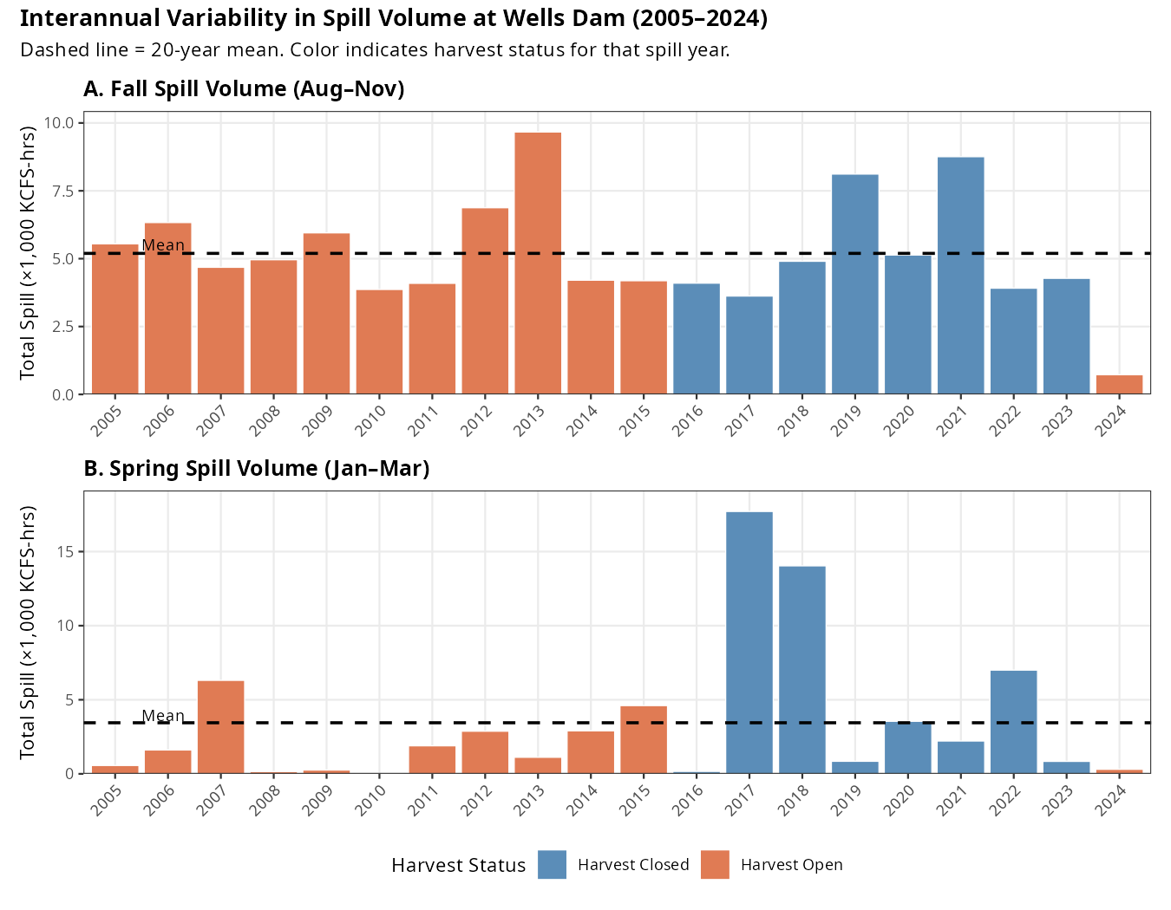
Figure 1. Interannual variability in total spill volume (KCFS-hours) at Wells Dam. Panel A: Fall (Aug–Nov). Panel B: Spring (Jan–Mar). Dashed line = 20-year mean. Orange bars = harvest-open years; blue bars = harvest-closed years (2016–2023). Note the substantially greater variability in the spring panel.

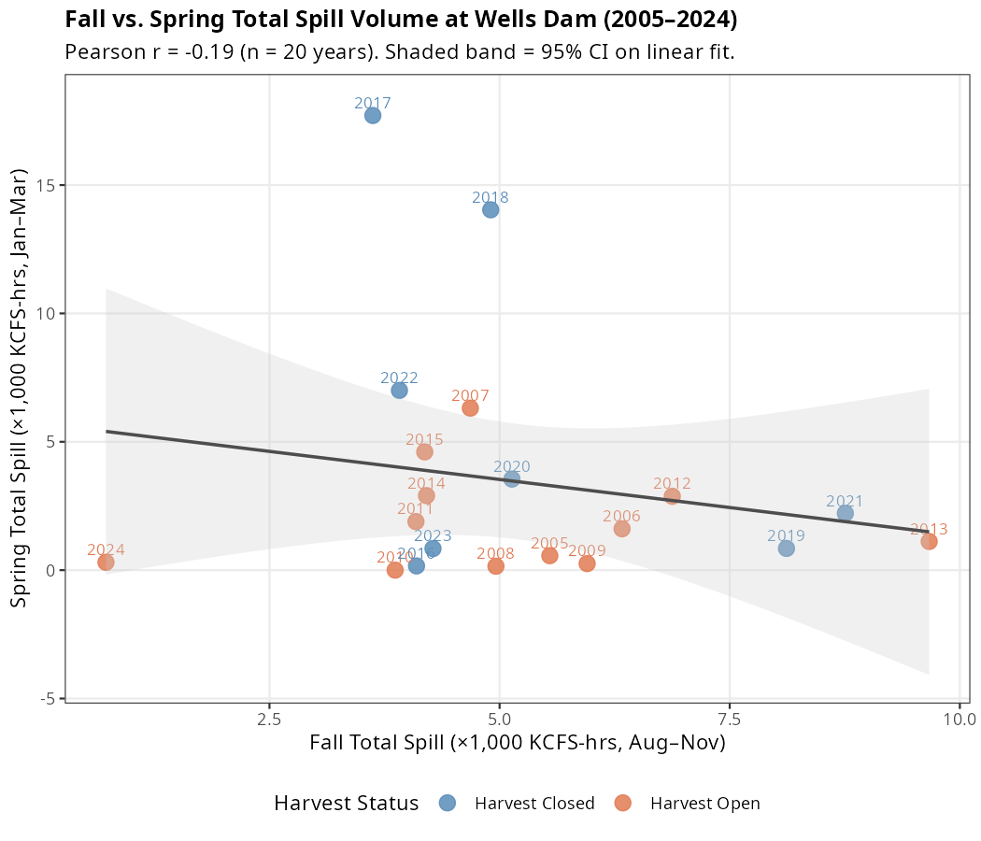
Figure 2. Scatter plot of fall vs. spring total spill volume by year. Each point represents one spill year, labeled by year. The linear fit (grey line, 95% CI shaded) shows a weak negative relationship (r = −0.19), confirming that fall and spring spill are essentially independent.

Year-to-Year Variation
The substantial year random effects (σ ≈ 0.5–0.7) indicate that factors beyond spill and harvest exposure influence annual variation in downstream return rates. Potential sources of this variation could include water temperature conditions affecting fish physiology and behavior, flow conditions affecting dam passage, fish condition and health varying by cohort, changes in detection infrastructure affecting apparent fates, and stochastic variation due to small sample sizes in some years.
The hierarchical model structure appropriately accounts for this variation through partial pooling, preventing any single unusual year from unduly influencing the overall inference.

Conclusions
Our findings complement the growing body of research on Columbia Basin steelhead overshoot. Murdoch et al. (2022) documented the abundance and migration success of overshoot steelhead but chose not to evaluate harvest exposure as a predictor because of assumed low harvest effects on wild steelhead. Richins and Skalski (2018) characterized overshoot patterns and identified temperature as a key driver but focused on overshoot occurrence rather than subsequent fate.
This study adds to the literature by demonstrating that post-overshoot fate is strongly associated with harvest exposure status but that fall and winter spill variation at Wells Dam does not explain Entiat and Wenatchee River return rates. The use of Bayesian hierarchical methods, as recommended for conservation applications (Thorson and Kristensen 2024; Scheuerell et al. 2015), provides principled uncertainty quantification and appropriate handling of the complex data structure.

References
Bürkner, P.-C. 2017. brms: An R package for Bayesian multilevel models using Stan. Journal of Statistical Software 80(1):1–28.
Bürkner, P.-C. 2018. Advanced Bayesian multilevel modeling with the R package brms. The R Journal 10(1):395–411.
Gelman, A., A. Jakulin, M. G. Pittau, and Y.-S. Su. 2008. A weakly informative default prior distribution for logistic and other regression models. Annals of Applied Statistics 2(4):1360–1383.
Ham, K.D., P.S. Titzler, R. P. Mueller, and R. Harnish. 2021. Evaluation of a Surface Spill Operation to Return Adult Steelhead Overshoots Downstream of McNary Dam. Final Report. Pacific Northwest National Laboratory. Richland, WA.
Keefer, M. L., and C. C. Caudill. 2014. Homing and straying by anadromous salmonids: a review of mechanisms and rates. Reviews in Fish Biology and Fisheries 24:333–368.
Keefer, M. L., C. A. Peery, T. C. Bjornn, M. A. Jepson, and L. C. Stuehrenberg. 2008. Hydrosystem, dam, and reservoir passage rates of adult Chinook salmon and steelhead in the Columbia and Snake rivers. Transactions of the American Fisheries Society 137:1185–1207.
Keefer, M.L, C.A. Peery and B. High. 2009 Behavioral Thermoregulation and Associated Mortality Trade-Offs in Migrating Adult Steelhead (Oncorhynchus Mykis): Variability Among Sympatric Populations. Canadian Journal of Fisheries and Aquatic Sciences 66:1734-1747.
Min, M.A, R.A., Buchanan, M.D. Scheuerell. 2025. Modeling Climate and Hydropower Influences on the Movement Decisions of an Anadromous Species. Global Change Biology 31:e70533.
Muir, W. D., S. G. Smith, J. G. Williams, and B. P. Sandford. 2001. Survival of juvenile salmonids passing through bypass systems, turbines, and spillways with and without flow deflectors at Snake River dams. North American Journal of Fisheries Management 21:135–146.
Murdoch, A. R., C. O. Ochieng, and C. M. Moffett. 2022. Abundance and migration success of overshoot steelhead in the Upper Columbia River. North American Journal of Fisheries Management 42:1066–1079.
NOAA Fisheries. 2024. Upper Columbia River steelhead. https://www.fisheries.noaa.gov/west-coast/endangered-species-conservation/upper-columbia-river-steelhead
Ogle, D. H. 2024. Bayesian LVB I - brms. fishR. https://fishr-core-team.github.io/fishR/blog/posts/2024-2-5_LVB_brms/
R Core Team. 2023. R: A language and environment for statistical computing. R Foundation for Statistical Computing, Vienna, Austria.
Richins, S. M., and J. R. Skalski. 2018. Steelhead overshoot and fallback rates in the Columbia–Snake River basin and the influence of hatchery and hydrosystem operations. North American Journal of Fisheries Management 38:1122–1137.
Scheuerell, M. D., C. P. Ruff, J. H. Anderson, and E. M. Beamer. 2015. Analyzing large-scale conservation interventions with Bayesian hierarchical models: a case study of supplementing threatened Pacific salmon. Ecology and Evolution 5:2115–2125.
Thorson, J. T., and K. Kristensen. 2024. Hierarchical Bayesian models in fisheries stock assessment. ICES Journal of Marine Science 81:fsad199.
WDFW (Washington Department of Fish and Wildlife). 2024. Steelhead management in Columbia and Snake River basins. https://wdfw.wa.gov/fishing/management/columbia-river

Appendix A
Steelhead Overshoot Analysis — Supplementary Spill Characterization

Overview
Seasonal dam spill at Wells Dam was characterized using three metrics for two time windows: cumulative spill volume (KCFS-hours), spill duration (hours with spill > 0), and spill days (days with any spill), each calculated for the fall steelhead arrival window (August 1–November 30) and the spring holding window (January 1–March 31). Spill years were assigned using a June 1 cutoff, pairing each fish with the fall conditions present during its arrival at Wells Dam and the spring conditions present during its holding period the following winter.
This document describes the interannual variability in these metrics across the 20-year study period, compares the two seasonal windows, and explains how the Bayesian hierarchical analysis model accounts for this variability in its inference about spill effects on steelhead downstream return probability.

Summary Statistics

Appendix A Table 1. Descriptive statistics for spill metrics at Wells Dam (2005–2024)
Metric | Mean | SD | Min (Year) | Max (Year) | CV (%)
Fall Total Spill (KCFS-hrs) | 5,195 | 2,021 | 724 (2024) | 9,667 (2013) | 39%
Fall Spill Hours | 535 | 158 | 52 (2024) | 725 (2021) | 30%
Fall Spill Days | 22 | 7 | 2 (2024) | 30 (2021) | 30%
Spring Total Spill (KCFS-hrs) | 3,448 | 4,738 | <1 (2010) | 17,709 (2017) | 137%
Spring Spill Hours | 146 | 162 | 1 (2010) | 671 (2018) | 111%
Spring Spill Days | 6 | 7 | 0 (2010) | 28 (2018) | 111%
CV = Coefficient of Variation (SD / Mean × 100%). Higher CV indicates greater interannual variability.

Appendix A Figure 1. Interannual variability in total spill volume (KCFS-hours) at Wells Dam. Panel A: Fall (Aug–Nov). Panel B: Spring (Jan–Mar). Dashed line = 20-year mean. Orange bars = harvest-open years; blue bars = harvest-closed years (2016–2023). Note the substantially greater variability in the spring panel.

Interannual Variability in Fall Spill (Aug–Nov)

Volume (Total Spill)
Fall cumulative spill volume ranged from 724 KCFS-hours in 2024 to 9,667 KCFS-hours in 2013—a 13-fold range (Appendix A Figure 1A). The coefficient of variation (CV) was 39%, indicating moderate interannual variability. Most years fell within 3,000–7,000 KCFS-hours, with 2013 and 2021 as clear high-spill outliers and 2024 as an exceptionally low-spill year. The mean over the 20-year period was 5,195 KCFS-hours.

Duration (Spill Hours and Days)
Fall spill duration was somewhat less variable than total volume (CV = 30%). Duration ranged from 52 hours in 2024 to 725 hours in 2021. Because spill volume and duration are closely related in this season, fall SpillHours and fall TotalSpill are highly correlated with one another—but they capture slightly different aspects of the spill regime (intensity vs. duration).
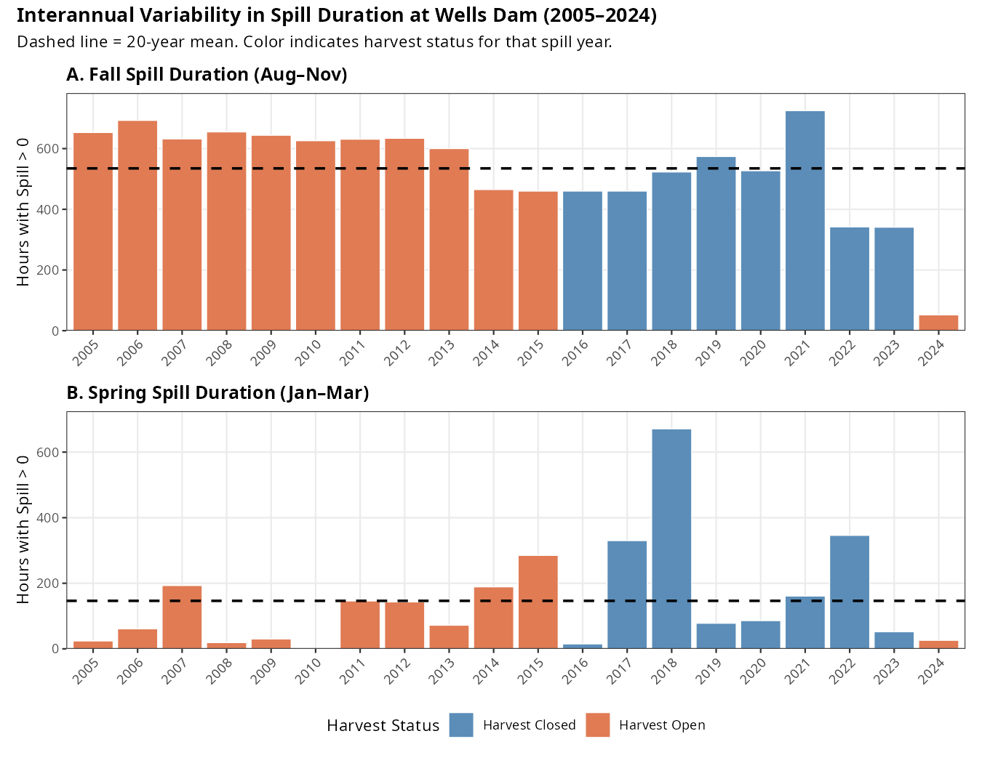
Appendix A Figure 2. Interannual variability in spill duration (hours with spill > 0) at Wells Dam. Panel A: Fall (Aug–Nov). Panel B: Spring (Jan–Mar). Dashed line = 20-year mean.

Temporal Pattern
Fall spill showed no significant temporal trend across the study period (slope = −65 KCFS-hrs/year, p = 0.42). Variation appears largely driven by annual hydrology rather than a directional change in dam operations. The anomalously low 2024 fall spill (724 KCFS-hours, less than 15% of the 20-year mean) stands out as an extreme departure from typical conditions.

Interannual Variability in Spring Spill (Jan–Mar)

Volume (Total Spill)
Spring cumulative spill volume exhibited dramatically greater interannual variability than fall spill, with a CV of 137%—more than three times the fall CV. Volume ranged from essentially zero (1 KCFS-hour in 2010) to 17,709 KCFS-hours in 2017 (Appendix A Figure 1B). This enormous range is driven by a bimodal pattern: a cluster of high-spill years (2017, 2018; both >14,000 KCFS-hours) associated with the harvest closure period, and many years with minimal spring spill (<2,000 KCFS-hours).
The two highest spring spill years (2017 and 2018) were nearly five times the 20-year mean of 3,448 KCFS-hours and reflect large snowpack and runoff conditions that produced substantial mandatory spill under FCRPS biological opinion requirements. Years 2010 and 2016 had near-zero spring spill, likely reflecting early season conditions where minimal water was available for non-power spill.

Duration (Spill Hours and Days)
Spring spill duration mirrored the volume pattern (CV = 111%). Duration ranged from 1 hour in 2010 to 671 hours in 2018. In contrast to fall, where Wells Dam spills during most hours of the season, spring spill is concentrated in a subset of years and hours driven by hydrology. In the near-zero spring spill years, fish may experience almost no spill during their holding period.

Temporal Pattern
Spring spill showed no significant temporal trend (slope = +166 KCFS-hrs/year, p = 0.38), though the two peak years (2017–2018) occur in the latter portion of the study period. This partly reflects the coincidence of high-precipitation years with the harvest closure period rather than a true directional trend.

Comparison Between Fall and Spring

Relative Variability
Spring spill is consistently more variable than fall spill across all three metrics:
- Total spill CV: Fall 39% vs. Spring 137%
- Spill hours CV: Fall 30% vs. Spring 111%
This difference reflects fundamentally different hydrological drivers. Fall spill at Wells Dam is relatively constrained by late-summer/early-fall hydropower operations and residual snowmelt, producing moderate and fairly consistent spill volumes. Spring spill is strongly governed by snowpack and February/March runoff, which varies dramatically from year to year in the Upper Columbia Basin.

Appendix A Figure 3. Scatter plot of fall vs. spring total spill volume by year. Each point represents one spill year, labeled by year. The linear fit (grey line, 95% CI shaded) shows a weak negative relationship (r = −0.19), confirming that fall and spring spill are essentially independent.

Seasonal Independence
Fall and spring spill metrics within the same spill year are essentially uncorrelated (Pearson r = −0.19 for total spill; r = −0.11 for spill hours; Appendix A Figure 3). A year with high fall spill does not reliably predict whether that same year will have high or low spring spill. This near-independence confirms that the two seasons are driven by different hydrological processes and that they provide genuinely distinct information in the models.

Absolute Scale Differences
Fall and spring seasons also differ substantially in average spill intensity. The fall window (122 days) produces roughly 50% more total cumulative spill on average than the spring window (90 days): 5,195 vs. 3,448 KCFS-hours. However, in peak spring years (2017, 2018), spring total spill exceeded fall by more than 3-fold.

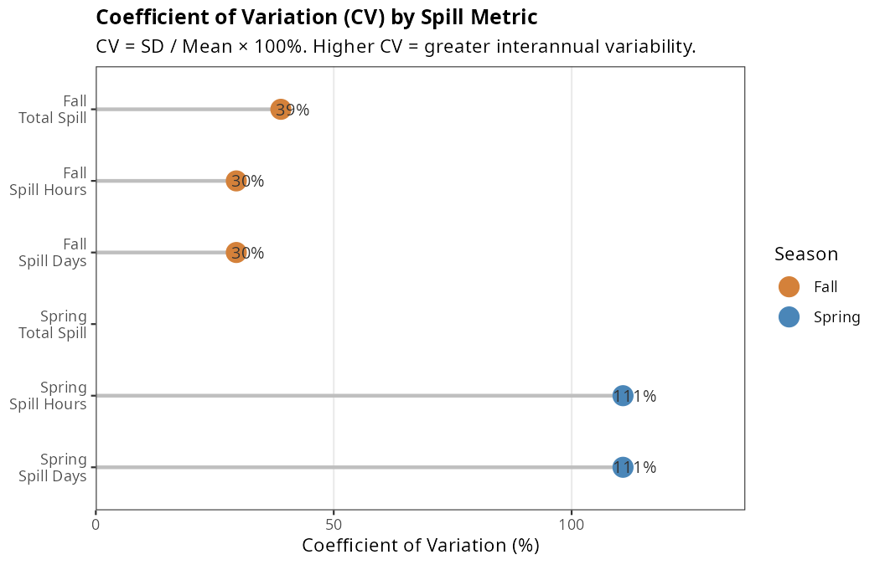
Appendix A Figure 4. Coefficient of variation (CV) for each spill metric. Higher CV indicates greater interannual variability. Spring metrics (blue) are consistently 3–4× more variable than fall metrics (orange).

Year-by-Year Spill Context
The figures below illustrate the full interannual pattern. Several notable years warrant specific attention:
- 2010: Near-zero spring spill (1 KCFS-hr), below-average fall spill. This was the highest-count year (286 fish), so the near-zero spring value has outsized influence on standardization.
- 2013: Highest fall spill volume (9,667 KCFS-hrs)—nearly double the 20-year mean.
- 2017–2018: Consecutive record-high spring spill years (17,709 and 14,037 KCFS-hrs), coinciding with the harvest closure and very small sample sizes (16 and 11 fish respectively).

- 2021: Highest fall spill duration (725 hours), though total volume was moderate.

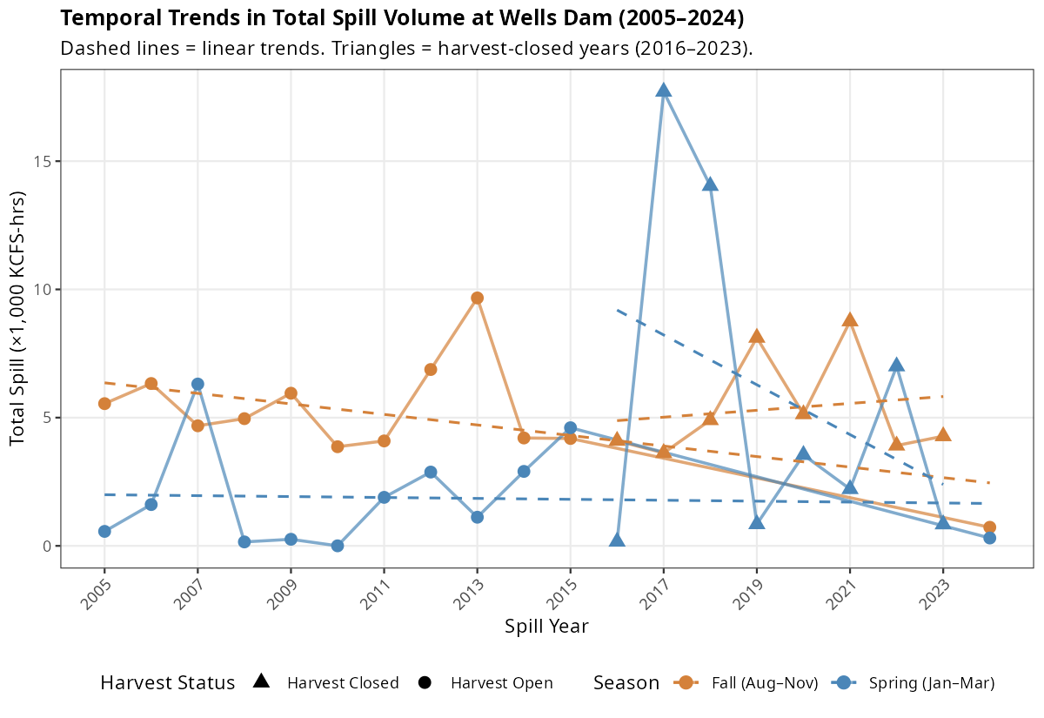
- 2024: Exceptionally low fall spill (724 KCFS-hrs), the lowest in the study period by a wide margin.
Appendix A Figure 5. Temporal trends in fall (orange) and spring (blue) total spill volume across the study period. Dashed lines = linear trends (neither statistically significant, p > 0.38). Triangles indicate harvest-closed years (2016–2023).

How the Model Accounts for Spill Variability

Standardization Before Model Entry
Prior to model fitting, all spill metrics were standardized to have mean = 0 and standard deviation = 1 (i.e., converted to z-scores). Figure 4 shows the standardized values for all six metrics across years.

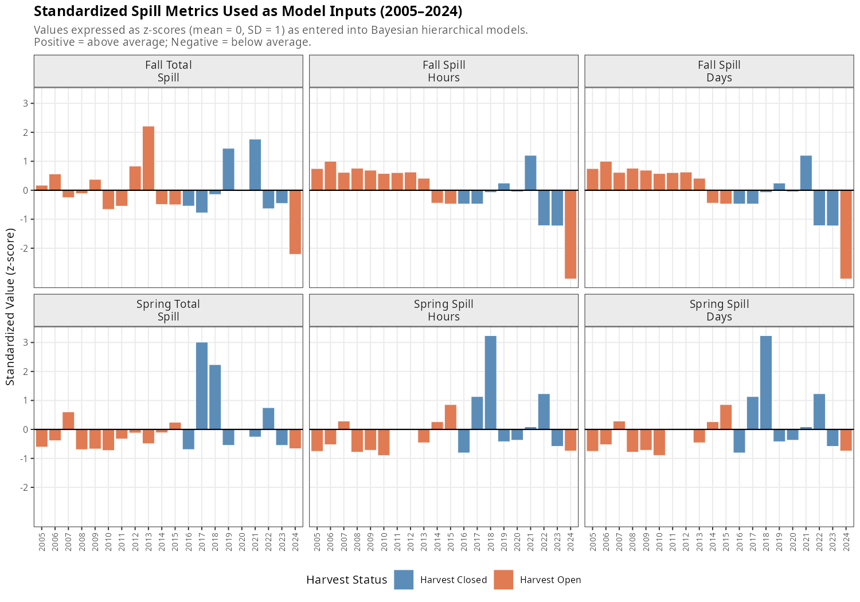
Appendix A Figure 6.

This serves two purposes. First, it places metrics with very different units and scales (KCFS-hours vs. days vs. hours) on a common, interpretable scale so that β_spill coefficients are comparable across models. Second, it prevents numerical instability in the Stan/HMC sampler when values span several orders of magnitude, as spring total spill does. Figure 4 shows the standardized values for all six metrics across years.
A practical consequence of standardization is that the change in log-odds of downstream return associated with a one-standard-deviation increase in spill. Because fall and spring spill have very different SDs (fall TotalSpill SD = 2,021 KCFS-hrs; spring TotalSpill SD = 4,738 KCFS-hrs), the same β_spill value corresponds to very different absolute changes in raw spill. For example, a β_spill of 0.10 applied to fall TotalSpill represents a response to ~2,000 KCFS-hrs of additional spill, while the same coefficient applied to spring TotalSpill represents a response to ~4,700 KCFS-hrs.

Year-Level Random Intercepts
The model includes year-specific random intercepts (α_j), estimated via partial pooling across all 20 spill years:
$$α_{j}∼\text{Normal}\left(μ_{α},σ_{α}\right)$$
These random intercepts absorb all year-to-year variation in the baseline probability of downstream return that is not explained by spill or harvest exposure. This is critical given the substantial interannual variability in spill metrics: if a year with extremely high spring spill also had high downstream return rates for unrelated reasons (e.g., low fish density, favorable temperature), the random intercept captures that coincidental association rather than attributing it spuriously to spill.
The estimated standard deviation of year random effects ranged from σ = 0.49 to 0.66 across the six models—a substantial amount of unexplained variation on the logit scale. This confirms that factors beyond spill and harvest exposure drive year-to-year differences in return rates, and that the random intercept structure is doing meaningful work.

Handling the High-Variability Spring Window
The extreme variability in spring spill creates a challenging estimation environment. The two years with by far the highest spring spill (2017: z = +3.0; 2018: z = +2.3) both fall within the harvest closure period (2016–2023) and have very small sample sizes (16 and 11 fish). This means that:
- The model must separate the effect of spring spill from the effect of harvest closure in years 2017–2018, relying on the within-year composition (harvest-exposed vs. non-exposed fish) and on other harvest-closure years with lower spring spill to identify the harvest effect.
- Small sample sizes in the high-spring-spill years increase uncertainty in the year random effects for those years, which propagates appropriately into wider posterior uncertainty for the spring spill coefficient.
The resulting spring spill estimates (β ≈ 0.03–0.09; 95% HDI spanning zero in all three metrics) reflect this uncertainty. The model correctly conveys that the data do not provide strong evidence for a spring spill effect, partly because the most informative spring spill contrasts involve small-sample years with potential confounding.

The Weak Spill Coefficient in Context
The near-zero spill effects estimated by the model should be interpreted against the backdrop of the substantial spill variability documented here. Fall TotalSpill ranged 13-fold and spring TotalSpill ranged over 12,000-fold across the study period. Despite this wide dynamic range—providing ample statistical leverage to detect a spill effect if one existed—neither seasonal metric produced a consistent, credible nonzero coefficient. The one exception (Fall SpillHours: β = −0.30, 95% HDI excluding zero) was not replicated by other fall metrics and likely reflects collinearity or confounding specific to the SpillHours metric rather than a genuine biological effect.
This makes the null spill finding relatively robust: the large interannual variation in spill metrics means the models had substantial power to detect a spill effect, yet none was found. In contrast, harvest exposure—a factor with a clear on/off structure but much smaller between-fish within-year variation—dominated the model estimates with an effect 7–10 times larger in absolute magnitude than any spill coefficient.

Prior Influence and Regularization
Weakly informative Normal(0, 1) priors were placed on both spill and harvest coefficients. On the logit scale, a coefficient of 1.0 corresponds to an odds ratio of e ≈ 2.7, and a coefficient of 2.0 corresponds to OR ≈ 7.4. The Normal(0, 1) prior is broad enough to allow large effects but provides mild regularization toward zero, which is appropriate for spill effects where the biological literature does not provide strong prior information about direction or magnitude. The estimated harvest coefficient (β ≈ −2.3) clearly overcomes this prior, while spill coefficients remain close to zero—consistent with the prior providing modest regularization for parameters where data support is weak.

Summary
The 20-year record of spill at Wells Dam is characterized by:
- Moderate interannual variability in fall spill (CV ≈ 30–39%), with most years producing 3,000–7,000 KCFS-hours of total spill and a 13-fold range between the lowest (2024) and highest (2013) years.
- Extreme interannual variability in spring spill (CV ≈ 111–137%), driven by snowpack-dependent hydrology. Two outlier years (2017, 2018) account for a disproportionate share of the total spring spill across the study period.
- No significant temporal trend in either season over 2005–2024.
- Near-zero correlation between fall and spring spill (r ≈ −0.19), confirming that the two seasons are driven by independent hydrological processes.
The Bayesian hierarchical model accounts for this variability through standardization of spill inputs, year-level random intercepts that absorb unexplained interannual variation, and weakly informative priors that allow the data—rather than prior assumptions—to determine the magnitude and direction of spill effects. Despite the wide dynamic range of spill conditions observed over the study period, neither seasonal window produced a consistent credible effect on steelhead downstream return probability. Harvest exposure, operating at the individual fish level, dominated the results with an effect size roughly an order of magnitude larger than any estimated spill coefficient.

Analysis conducted March 2026
Data source: Columbia River DART hourly spill records, Wells Dam (WELW), 2000–2024
Statistical software: R 4.3.2 with ggplot2, tidyverse, patchwork

